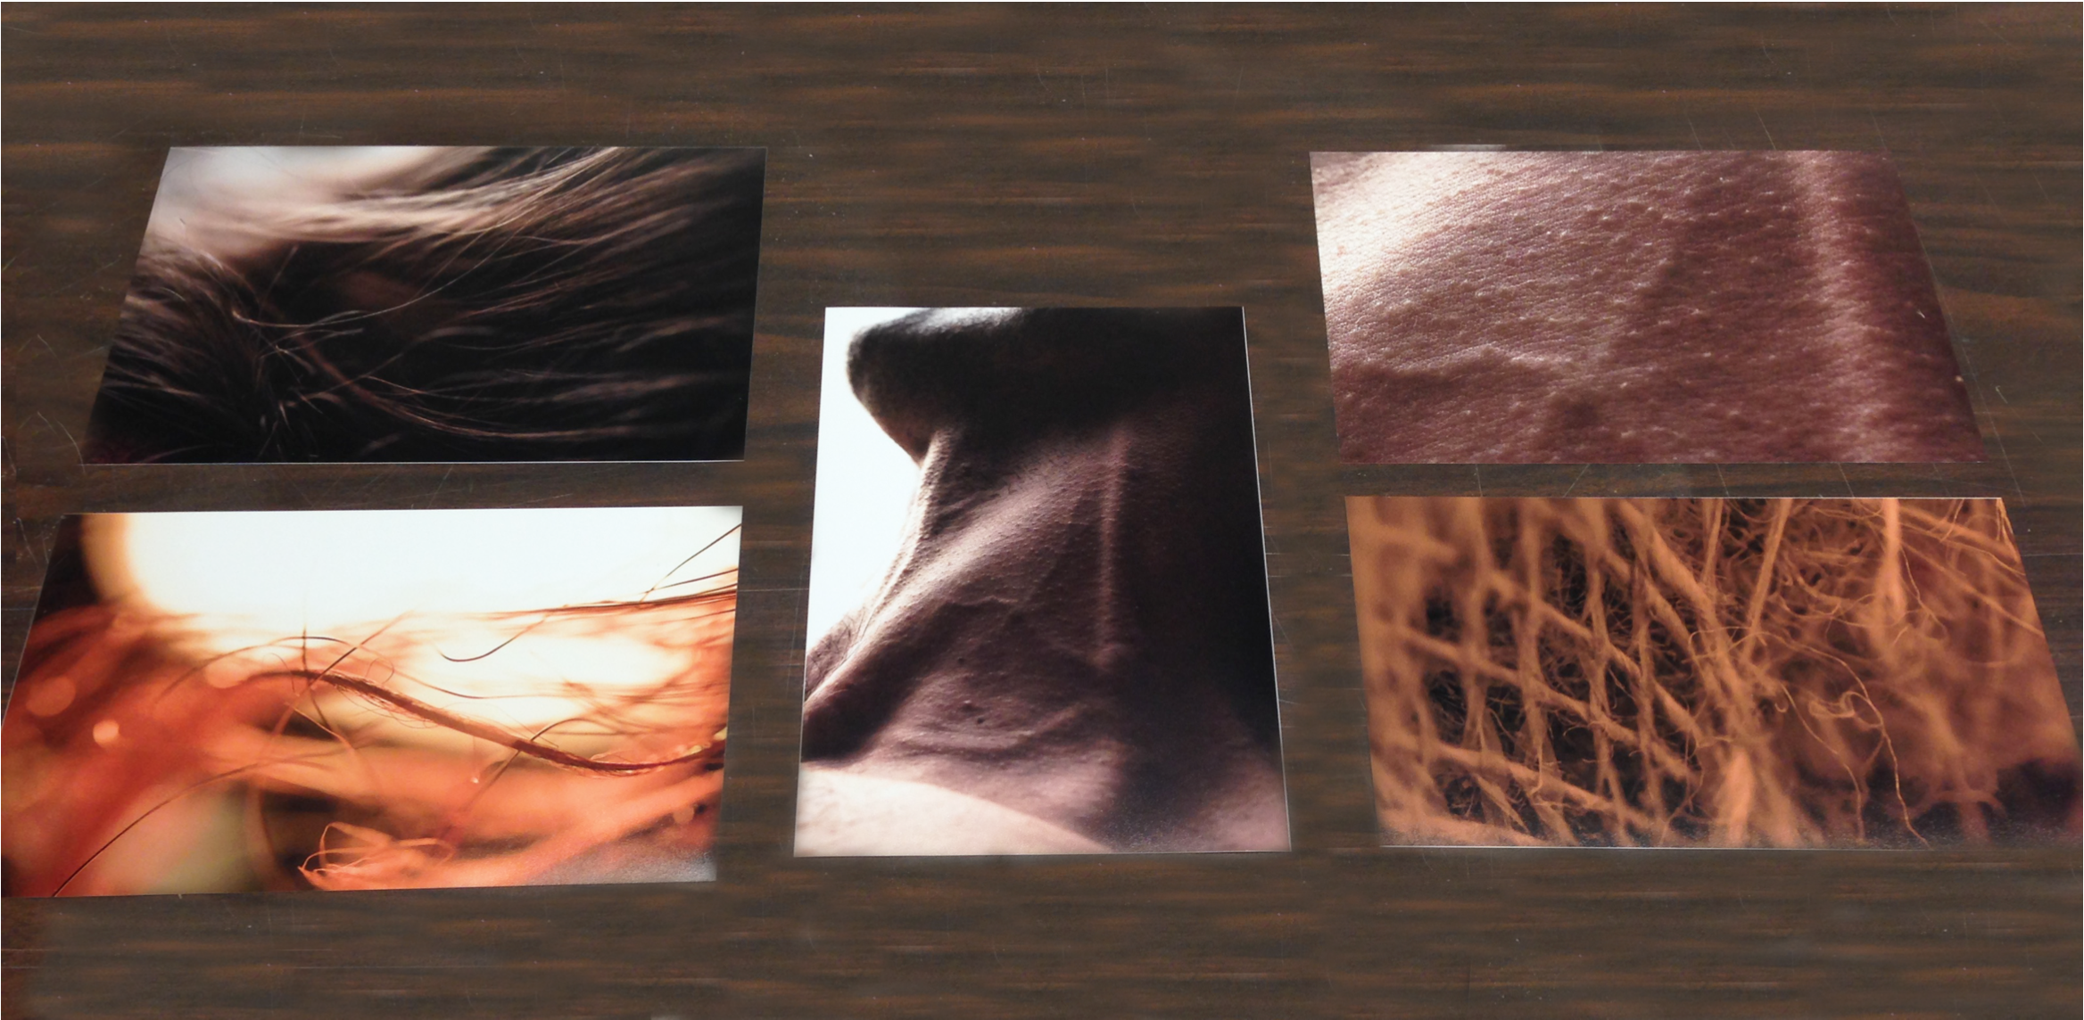

Paper & Ink

11.5” x 8”

Received: 3.6

Time Spent: 6 hours

Initial Reaction: 7/10

Cost of Materials: $18

This work was received well in crit and received an overall grade of 3.6 upon evaluation. The total hours/money spent on labor and cost of materials was below average.

Add To Cart: **$13.32** [See Pricing Sheet](Pricing%20Sheet.docx)

Photoshop & Digital Image

? x ?

Received: 3.6

Time Spent: 5 hours

Initial Reaction: 5/10

Cost of Materials: $18

This work was received not so well in crit and received an overall grade of 3.6 upon evaluation. The total hours/money spent on labor and cost of materials was below average.

Add To Cart: **$11.1** [See Pricing Sheet](Pricing%20Sheet.docx)

